
A PROJECT REPORT ON

“Public Cyber Incident Reporting Portal”

SUBMITTED TO
Ajeenkya DY Patil University, Pune

UNDER THE GUIDANCE OF
MR. RAVI KHATRI

(ADVANCE DATABASE MANAGEMENT SYSTEM)
(M.C.A(CSDF) 2025-2026) SEMESTER-I
BY:
Sakshi Aru
Sagar Jadhav

YEAR-2025-2026

Part A — Cassandra (CQL) Design and Queries
Overview:
Apache Cassandra is an open-source, distributed NoSQL database designed to handle massive amounts of data across many commodity servers, providing high availability and linear scalability without sacrificing performance.
Key Characteristics:
- NoSQL and Wide-Column Store: Cassandra is a NoSQL database, meaning it doesn't use the traditional relational model. Instead, it employs a wide-column store model, offering flexibility in schema design and efficient storage of sparse data.
- Distributed Architecture: Data is distributed across multiple nodes in a peer-to-peer cluster, with no single point of failure. This design ensures high availability and fault tolerance.
- Tunable Consistency: While Cassandra defaults to an AP (Availability and Partition Tolerance) system under the CAP theorem, prioritizing availability, it offers tunable consistency levels. This allows users to adjust the consistency guarantees for both read and write operations based on application requirements.
- High Availability and Scalability: Its distributed nature and replication strategies provide continuous service even during node failures or planned downtime. Cassandra scales linearly, meaning performance increases with the addition of new nodes.
- Data Model: Cassandra's data model is driven by application needs and requires careful consideration of query patterns during schema design. It utilizes keyspaces (containers for replication) and tables, which are accessed using the Cassandra Query Language (CQL).
- Compaction Strategies: Cassandra employs various compaction strategies (e.g., Size-tiered, Leveled, TimeWindow) to optimize data storage and retrieval, especially for read-heavy or time-series workloads.
- Use Cases: Cassandra is widely used in applications requiring high write throughput, massive data storage, and continuous availability, such as social media platforms, IoT data management, and real-time analytics.

STEP 1 — Install Java (required for Cassandra)
#sudo apt update
#sudo apt install openjdk-11-jdk -y
Verify installation:
#java -version
STEP 2 — Add Apache Cassandra Repository
#echo "deb https://debian.cassandra.apache.org 41x main" | sudo tee /etc/apt/sources.list.d/cassandra.sources.list
Add GPG key
#curl https://downloads.apache.org/cassandra/KEYS | sudo apt-key add -
Update packages
#sudo apt update
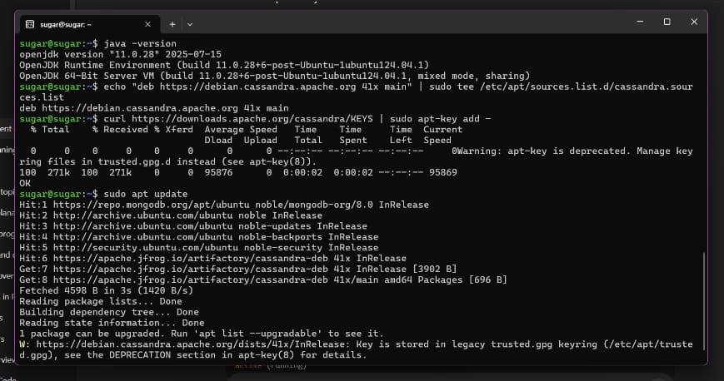
STEP 3 — Start Cassandra service
#sudo systemctl enable cassandra
#sudo systemctl start cassandra
#sudo systemctl status cassandra
STEP 4 — Open CQL shell
#cqlsh
if it works, you will see:
cqlsh>
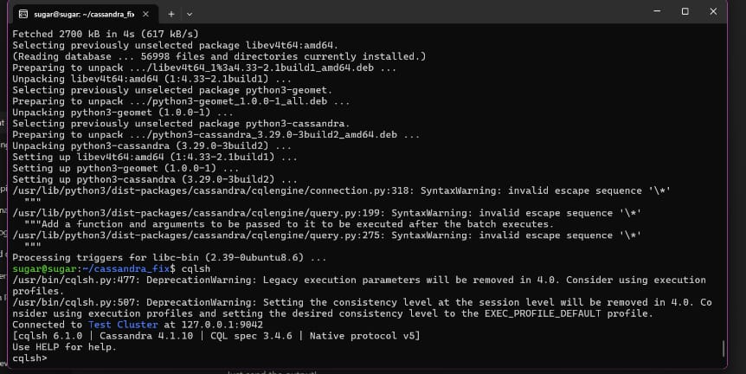

Then its working..
Now we start with Part A- (Database Implementation in Cassandra) for our topic:

Public Cyber Incident Reporting Portal
We will do this step–by–step, and you will run each command inside cqlsh.

STEP 1: Create Keyspace
Go to your terminal (inside cqlsh> prompt) and run:
# CREATE KEYSPACE cyber_portal WITH replication = {
'class': 'SimpleStrategy',
'replication_factor': 1
};
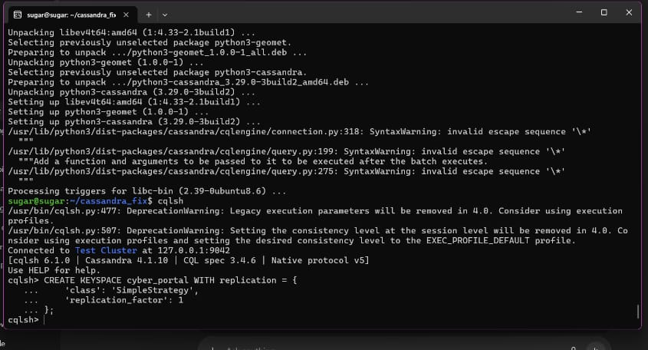
Then switch to it:
# USE cyber_portal;

STEP 2: Create Tables
A cyber incident reporting portal needs these main tables:
- Users Table
# CREATE TABLE users (
user_id UUID PRIMARY KEY,
name text,
email text,
phone text,
address text,
created_at timestamp
);
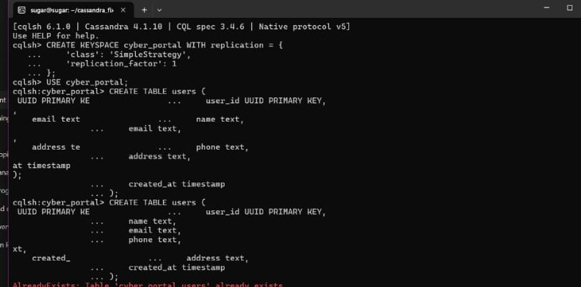

Cyber Incidents Table
Stores general incident information.
#CREATE TABLE cyber_incidents (
incident_id UUID PRIMARY KEY,
reported_by UUID,
category text,
severity text,
description text,
reported_at timestamp
);
- Incident Reports Table
Stores detailed reports attached to an incident
(uses incident_id as partition key and report_id as clustering key).
# CREATE TABLE incident_reports (
incident_id UUID,
report_id UUID,
report_details text,
attached_evidence text,
created_at timestamp,
PRIMARY KEY (incident_id, report_id)
);
- Response Teams Table
# CREATE TABLE response_teams (
team_id UUID PRIMARY KEY,
team_name text,
contact_number text,
region text
);
Image for 2,3 and 4 TABLES
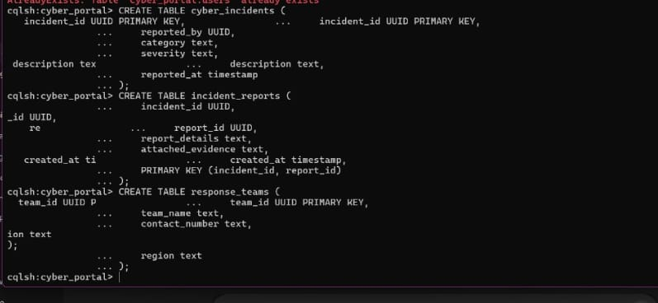

Incident Status Log Table
Tracks the status changes of each incident.
# CREATE TABLE incident_status_log (
incident_id UUID,
status_time timestamp,
status text,
updated_by UUID,
remarks text,
PRIMARY KEY (incident_id, status_time)
);

STEP 3: Insert Sample Data

Insert Users
#INSERT INTO users (user_id, name, email, phone, address, created_at)
VALUES (uuid(), 'Rohan Sharma', 'rohan@gmail.com', '9876543210', 'Delhi, India', toTimestamp(now()));

INSERT INTO users (user_id, name, email, phone, address, created_at)
VALUES (uuid(), 'Priya Verma', 'priya@gmail.com', '9812345670', 'Mumbai, India', toTimestamp(now()));
IMAGE FOR Table 5 and Insert Users
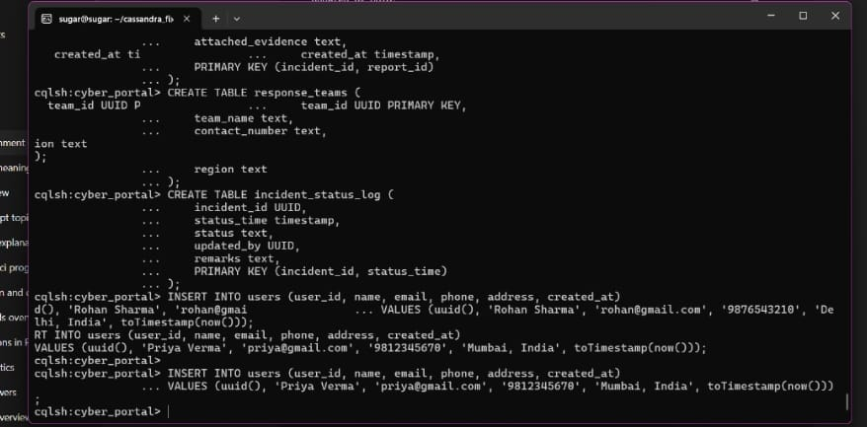

Insert Cyber Incidents
# INSERT INTO cyber_incidents (incident_id, reported_by, category, severity, description, reported_at)
VALUES (uuid(), uuid(), 'Phishing', 'High', 'Fake bank email asking for OTP', toTimestamp(now()));

INSERT INTO cyber_incidents (incident_id, reported_by, category, severity, description, reported_at)
VALUES (uuid(), uuid(), 'Malware Attack', 'Critical', 'Ransomware attack on system files', toTimestamp(now()));
3.Insert Incident Reports
# INSERT INTO incident_reports (incident_id, report_id, report_details, attached_evidence, created_at)
VALUES (uuid(), uuid(), 'User submitted screenshots of suspicious email', 'email_screenshot.jpg', toTimestamp(now()));
IMAGE OF 2 AND 3.
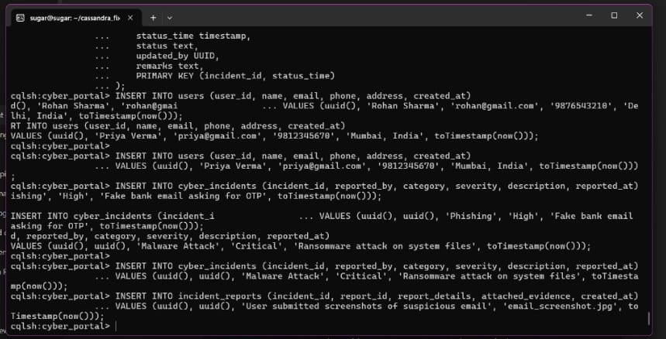

4. Insert Response Teams
INSERT INTO response_teams (team_id, team_name, contact_number, region)VALUES (uuid(), 'CERT-Delhi', '1800-111-234', 'North Region');
INSERT INTO response_teams (team_id, team_name, contact_number, region)VALUES (uuid(), 'CERT-Mumbai', '1800-222-345', 'West Region');

5. Insert Status Log
INSERT INTO incident_status_log (incident_id, status_time, status, updated_by, remarks)VALUES (uuid(), toTimestamp(now()), 'Investigating', uuid(), 'Team assigned and analysis started');

Image for 4 and 5.
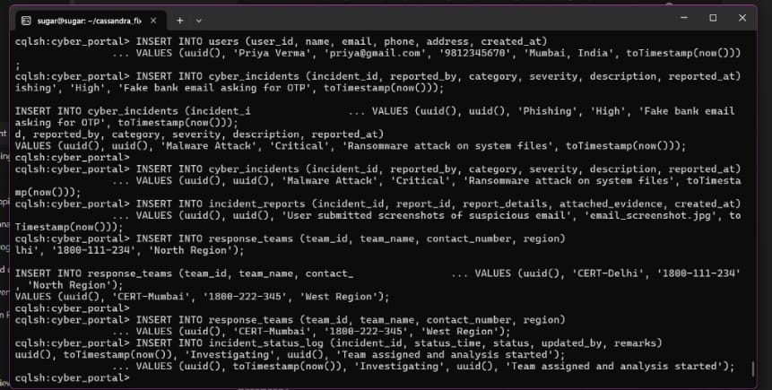

Here part A is completed some queries are there now part B.

STEP 1 — Open CQL shell
#cqlsh

Part B - Execution of More Queries.

PUBLIC CYBER INCIDENT REPORTING PORTAL – CASSANDRA CQL IMPLEMENTATION
Your domain:
🚨 Public Cyber Incident Reporting Portal
People report cyber incidents → officials review → notifications sent → resolution actions logged.
This is the full Cassandra implementation.

CORE PROBLEM & PRIMARY OBJECTIVES :-
Core Problems:-Citizens report cyber incidents (phishing, hacking, identity theft), but:
- There is no centralized reporting platform
- Response teams cannot track incidents in real-time
- Victim notification is inconsistent
- No audit trail exists for forensic analysis
Objectives:-
- Store public-reported cyber incidents
- Track review status by cyber officials
- Notify victims or reporters
- Log every response/resolution step
- Generate insights (severity, location trends, status)
- KEYSPACE CREATION
#CREATE KEYSPACE IF NOT EXISTS cyber_portal
WITH replication = {'class': 'SimpleStrategy', 'replication_factor': 1};

TABLE 1: citizen_incident_report:- :-:-: - Stores all citizen-reported public cyber incidents
#USE cyber_portal;

-- Create the table if it doesn't exist
CREATE TABLE IF NOT EXISTS citizen_incident_report (
incident_id uuid PRIMARY KEY,
citizen_id uuid,
citizen_name text,
contact_email text,
incident_date date,
location text,
incident_type text,
severity text,
status text,
assigned_team text,
created_at timestamp,
updated_at timestamp
);

-- Insert multiple rows in one batch
BEGIN BATCH

INSERT INTO citizen_incident_report (
incident_id, citizen_id, citizen_name, contact_email, incident_date,
location, incident_type, severity, status, assigned_team, created_at, updated_at
) VALUES (
uuid(), uuid(), 'Amit Sharma', 'amit@gmail.com', '2025-11-10',
'Delhi', 'Phishing Attack', 'High', 'Pending Review', 'Cyber Cell A',
toTimestamp(now()), toTimestamp(now())
);

INSERT INTO citizen_incident_report (
incident_id, citizen_id, citizen_name, contact_email, incident_date,
location, incident_type, severity, status, assigned_team, created_at, updated_at
) VALUES (
uuid(), uuid(), 'Riya Patel','riya@yahoo.com','2025-10-02',
'Mumbai','Online Scam','Medium','Resolved','Cyber Cell B',
toTimestamp(now()),toTimestamp(now())
);

INSERT INTO citizen_incident_report (
incident_id, citizen_id, citizen_name, contact_email, incident_date,
location, incident_type, severity, status, assigned_team, created_at, updated_at
) VALUES (
uuid(), uuid(), 'John Dsouza','john@outlook.com','2025-09-12',
'Bangalore','Identity Theft','Critical','Investigating','Cyber Cell C',
toTimestamp(now()),toTimestamp(now())
);

INSERT INTO citizen_incident_report (
incident_id, citizen_id, citizen_name, contact_email, incident_date,
location, incident_type, severity, status, assigned_team, created_at, updated_at
) VALUES (
uuid(), uuid(), 'Sneha Singh','sneha@gmail.com','2025-11-01',
'Chennai','Account Hacked','Low','Pending Review','Cyber Cell A',
toTimestamp(now()),toTimestamp(now())
);

INSERT INTO citizen_incident_report (
incident_id, citizen_id, citizen_name, contact_email, incident_date,
location, incident_type, severity, status, assigned_team, created_at, updated_at
) VALUES (
uuid(), uuid(), 'Farhan Ali','farhan@live.com','2025-08-21',
'Hyderabad','Cyberbullying','Medium','Closed','Cyber Cell B',
toTimestamp(now()),toTimestamp(now())
);

INSERT INTO citizen_incident_report (
incident_id, citizen_id, citizen_name, contact_email, incident_date,
location, incident_type, severity, status, assigned_team, created_at, updated_at
) VALUES (
uuid(), uuid(), 'Anushka Verma','anushka@gmail.com','2025-07-15',
'Pune','Data Leak','High','Under Review','Cyber Cell C',
toTimestamp(now()),toTimestamp(now())
);

INSERT INTO citizen_incident_report (
incident_id, citizen_id, citizen_name, contact_email, incident_date,
location, incident_type, severity, status, assigned_team, created_at, updated_at
) VALUES (
uuid(), uuid(), 'Karan Mehta','karan@hotmail.com','2025-08-17',
'Kolkata','Hacking Attempt','Low','Pending Review','Cyber Cell D',
toTimestamp(now()),toTimestamp(now())
);

INSERT INTO citizen_incident_report (
incident_id, citizen_id, citizen_name, contact_email, incident_date,
location, incident_type, severity, status, assigned_team, created_at, updated_at
) VALUES (
uuid(), uuid(), 'Meera Nair','meera@rediff.com','2025-05-20',
'Delhi','Online Fraud','Critical','Escalated','Cyber Cell A',
toTimestamp(now()),toTimestamp(now())
);
APPLY BATCH;
Images for 2 and 3
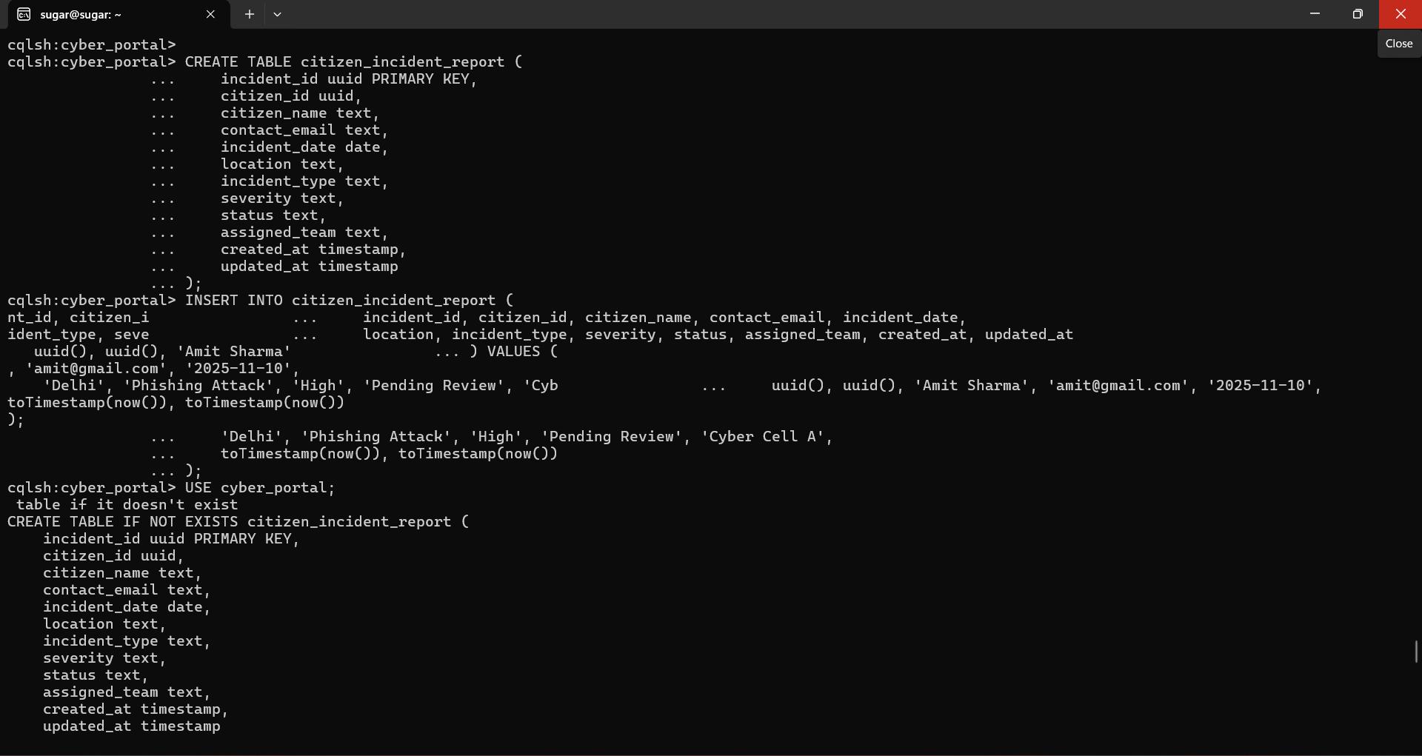
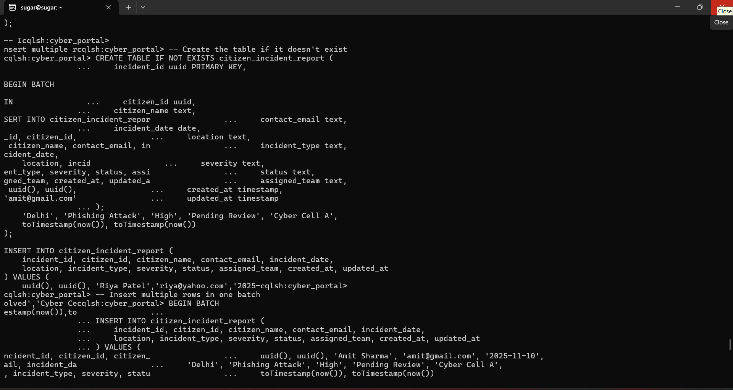
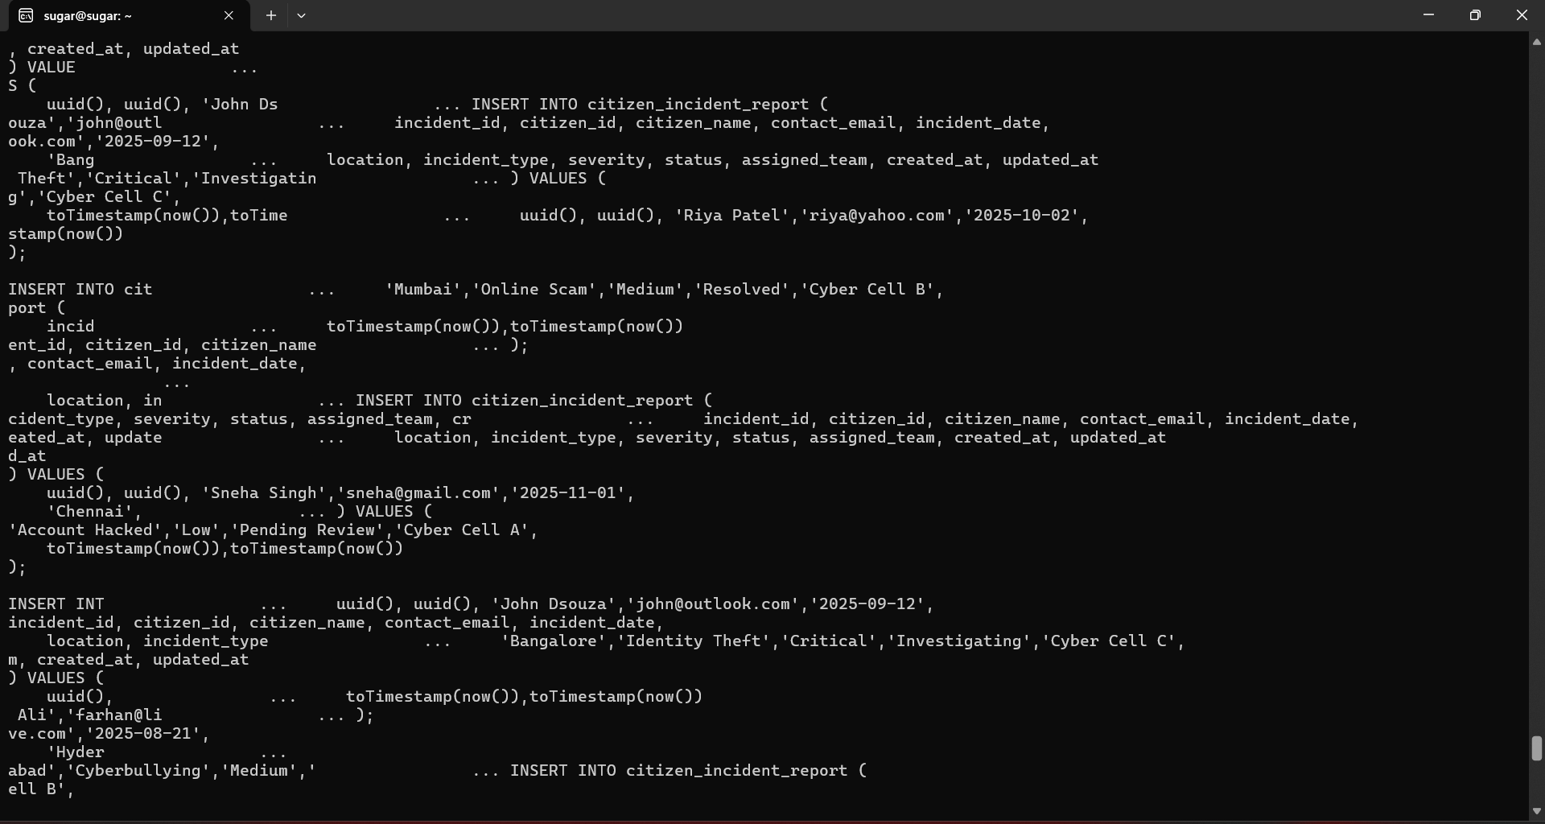
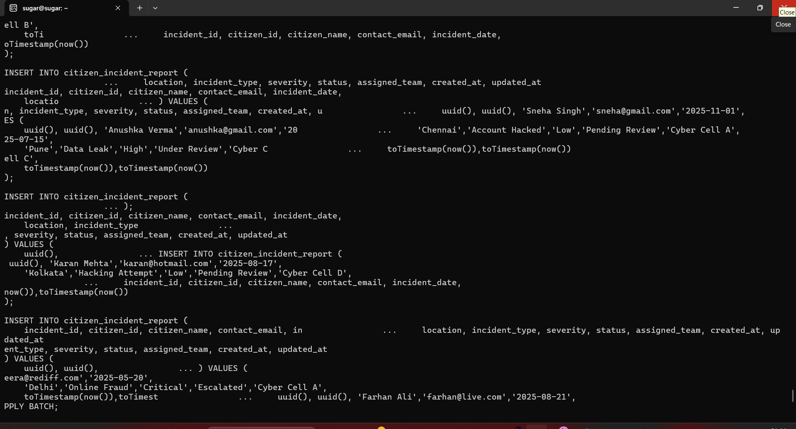

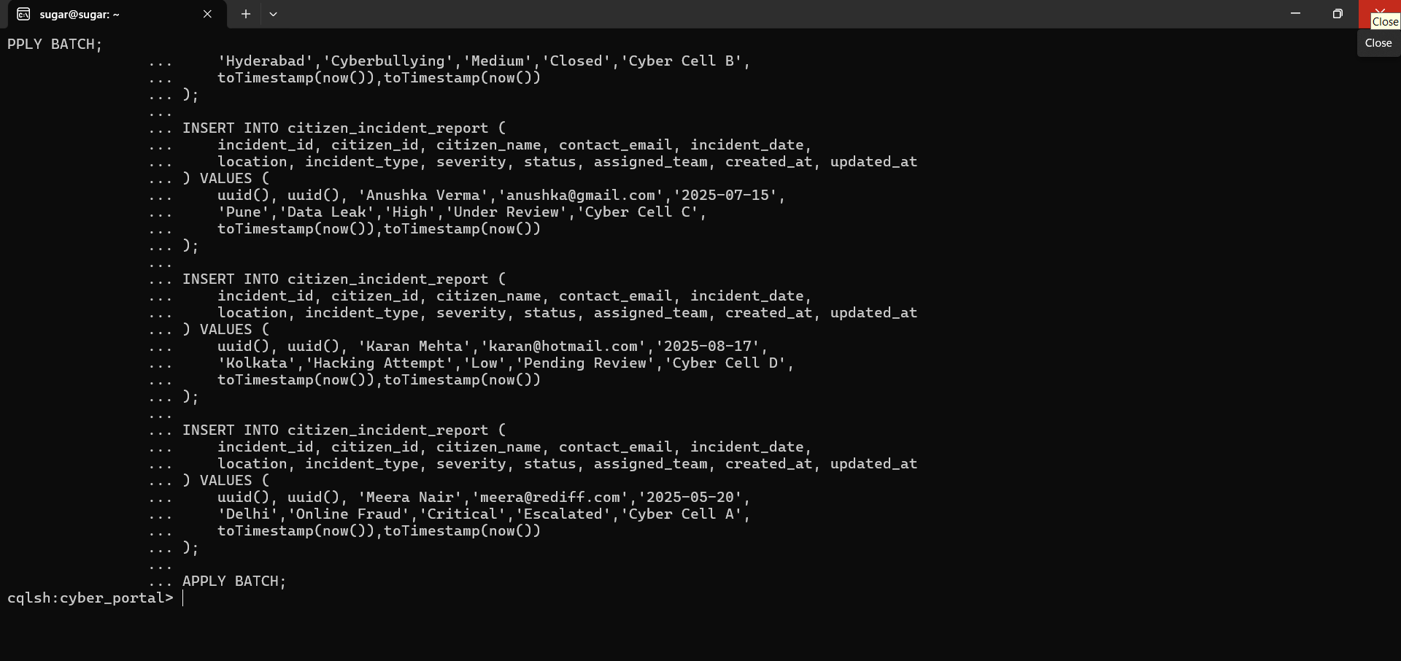

1.Retrieve all reported incidents
#SELECT * FROM cyber_portal.citizen_incident_report;
2.Find incidents by severity
#SELECT incident_id, citizen_name, incident_type, status
FROM cyber_portal.citizen_incident_report
WHERE severity = 'High' ALLOW FILTERING;

Image of 1 and 2
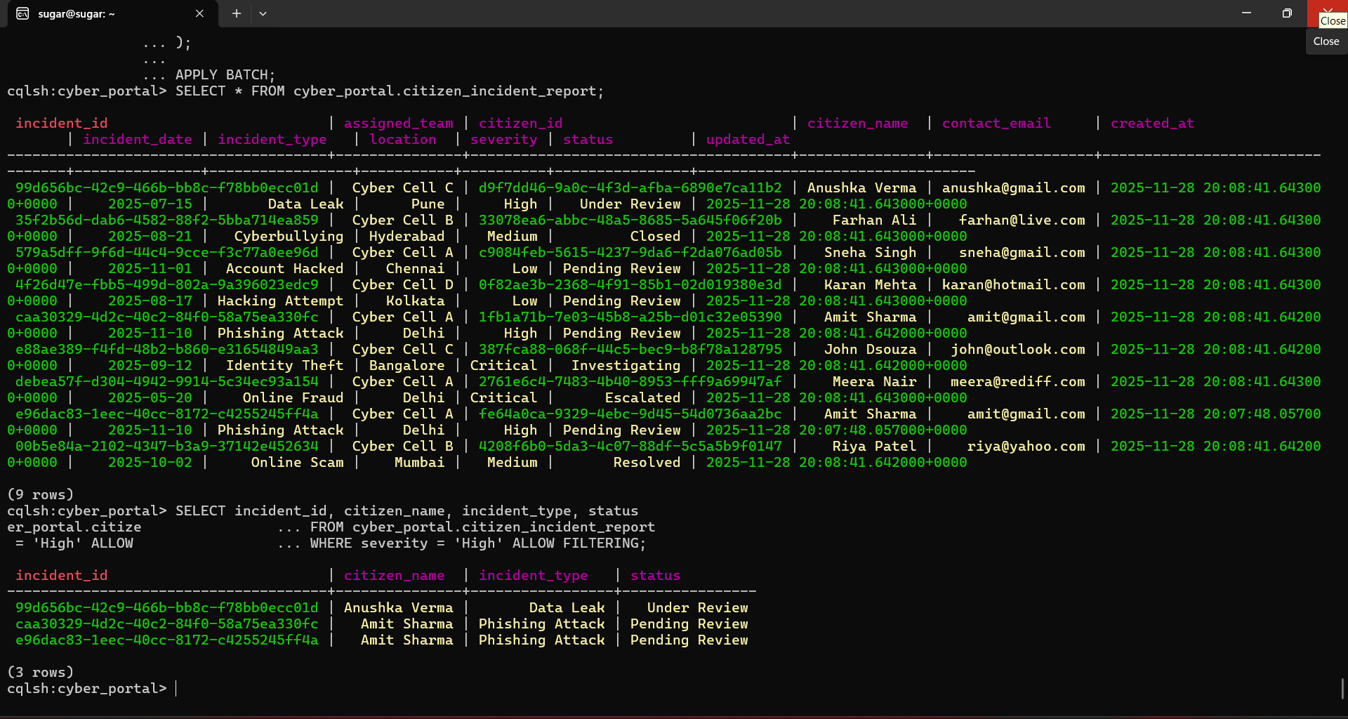
3.Fetch incidents for a specific city
#SELECT * FROM cyber_portal.citizen_incident_report
WHERE location = 'Delhi' ALLOW FILTERING;
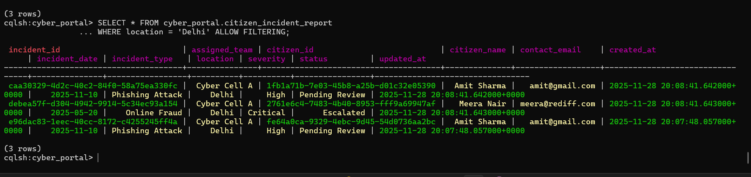

Table 2: victim_notification
- Purpose: Stores notifications sent to citizens after incident review.
#CREATE TABLE IF NOT EXISTS cyber_portal.victim_notification (
incident_id UUID,
citizen_email TEXT,
notification_date TIMESTAMP,
notification_method TEXT,
is_notified BOOLEAN,
PRIMARY KEY (incident_id, citizen_email)
);

2.Insert Sample Records
#INSERT INTO cyber_portal.victim_notification (
incident_id, citizen_email, notification_date, notification_method, is_notified
) VALUES (1209679d-6d9e-404b-95cd-6fbacd260ccb, 'amit@gmail.com', toTimestamp(now()), 'Email', true);

INSERT INTO cyber_portal.victim_notification (
incident_id, citizen_email, notification_date, notification_method, is_notified
) VALUES (471afa11-566e-47da-aca7-538f4e4994e3, 'riya@yahoo.com', toTimestamp(now()), 'SMS', true);

INSERT INTO cyber_portal.victim_notification (
incident_id, citizen_email, notification_date, notification_method, is_notified
) VALUES (d973fc76-0dc9-4097-bb54-9730c3f92f31, 'john@outlook.com', toTimestamp(now()), 'Email', false);

INSERT INTO cyber_portal.victim_notification (
incident_id, citizen_email, notification_date, notification_method, is_notified
) VALUES (58709998-610d-4f14-96c9-7e8bcb00333a, 'sneha@gmail.com', toTimestamp(now()), 'Call', true);

INSERT INTO cyber_portal.victim_notification (
incident_id, citizen_email, notification_date, notification_method, is_notified
) VALUES (7b9dc019-4351-480a-b6d2-98ce8c961ec0, 'farhan@live.com', toTimestamp(now()), 'Email', false);

INSERT INTO cyber_portal.victim_notification (
incident_id, citizen_email, notification_date, notification_method, is_notified
) VALUES (968ed8ae-8dff-4a13-aabb-b8066a45833e, 'anushka@gmail.com', toTimestamp(now()), 'SMS', true);

INSERT INTO cyber_portal.victim_notification (
incident_id, citizen_email, notification_date, notification_method, is_notified
) VALUES (cf98402d-fbf8-4226-ad48-fe3de308a3b2, 'karan@hotmail.com', toTimestamp(now()), 'Email', true);

INSERT INTO cyber_portal.victim_notification (
incident_id, citizen_email, notification_date, notification_method, is_notified
) VALUES (a5eb5f04-9e0f-4924-a0b0-e65fc56555f0, 'meera@rediff.com', toTimestamp(now()), 'SMS', false);

3.View all notifications
#SELECT * FROM cyber_portal.victim_notification;
4.View only notified victims
#SELECT incident_id, citizen_email, notification_method
FROM cyber_portal.victim_notification
WHERE is_notified = true ALLOW FILTERING;

Images of 1,2,3 and 4.
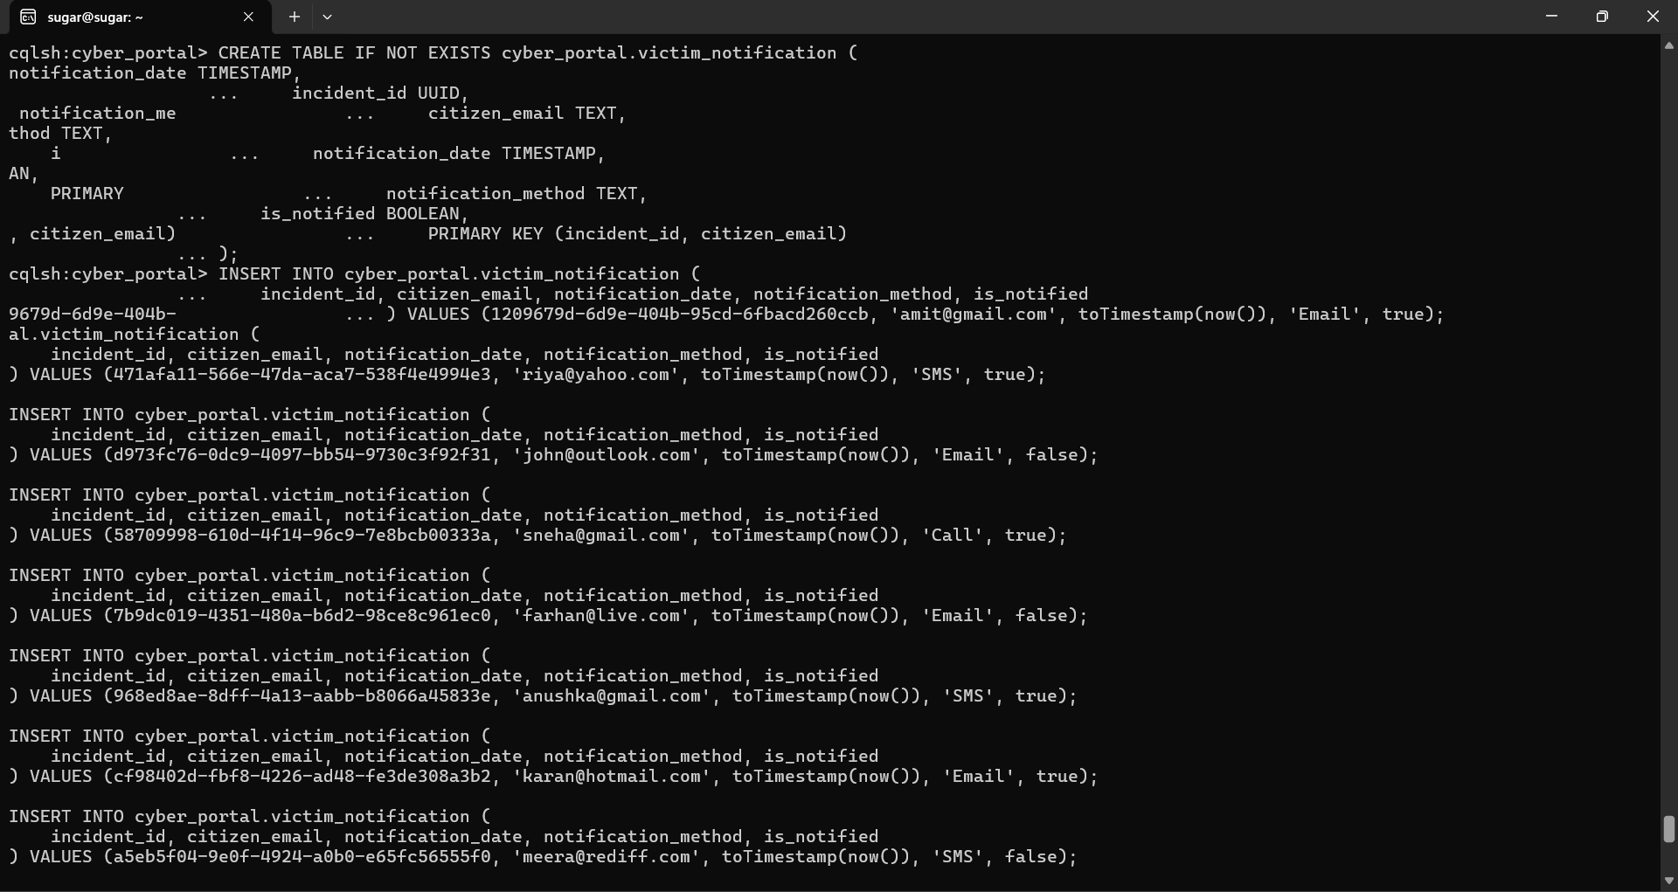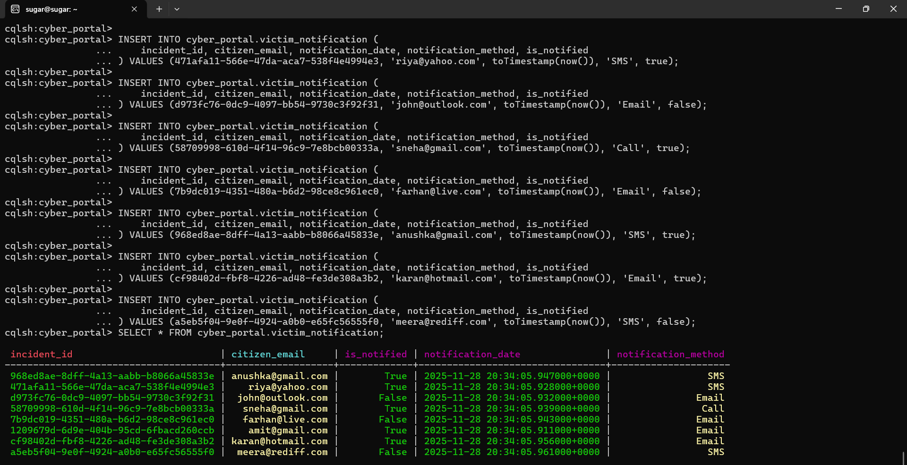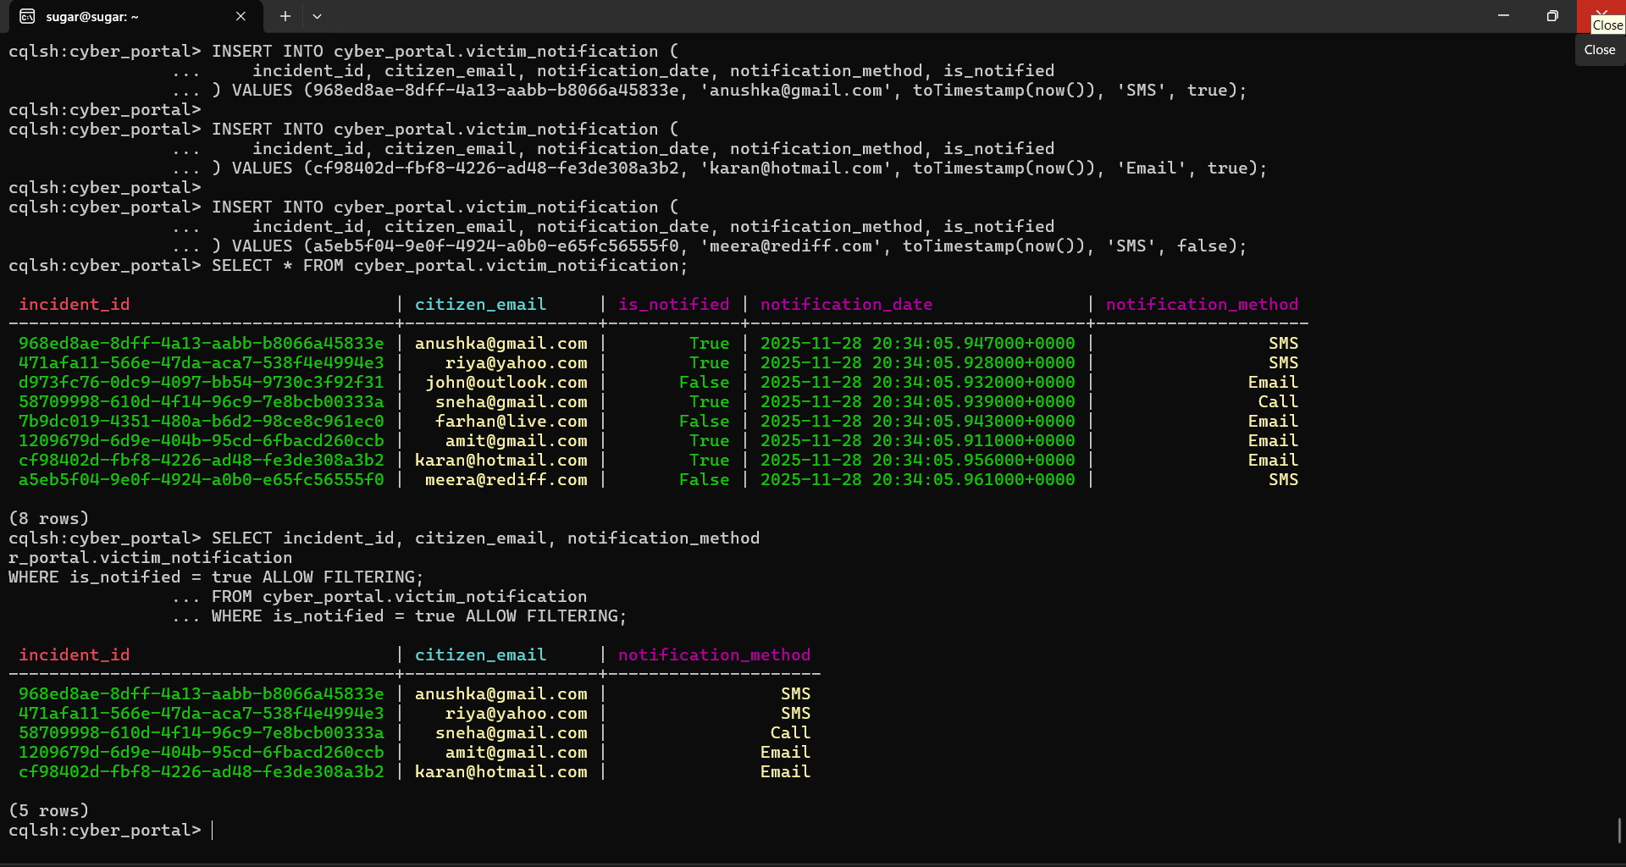

Table 3: incident_resolution_log
Purpose: Tracks action steps taken by cyber response teams.
1.Create Table
#CREATE TABLE IF NOT EXISTS cyber_portal.incident_resolution_log (
incident_id UUID,
step_id TIMEUUID,
action_taken TEXT,
action_by TEXT,
action_time TIMESTAMP,
PRIMARY KEY (incident_id, step_id)
) WITH CLUSTERING ORDER BY (step_id DESC);

Insert Sample Records
INSERT INTO cyber_portal.incident_resolution_log (
incident_id, step_id, action_taken, action_by, action_time
) VALUES (1209679d-6d9e-404b-95cd-6fbacd260ccb, now(), 'Incident verified', 'Cyber Officer', toTimestamp(now()));

INSERT INTO cyber_portal.incident_resolution_log (
incident_id, step_id, action_taken, action_by, action_time
) VALUES (471afa11-566e-47da-aca7-538f4e4994e3, now(), 'Evidence collected', 'Cyber Team', toTimestamp(now()));

INSERT INTO cyber_portal.incident_resolution_log (
incident_id, step_id, action_taken, action_by, action_time
) VALUES (d973fc76-0dc9-4097-bb54-9730c3f92f31, now(), 'Victim contacted', 'Support Agent', toTimestamp(now()));

INSERT INTO cyber_portal.incident_resolution_log (
incident_id, step_id, action_taken, action_by, action_time
) VALUES (58709998-610d-4f14-96c9-7e8bcb00333a, now(), 'Technical analysis ongoing', 'SOC Analyst', toTimestamp(now()));

INSERT INTO cyber_portal.incident_resolution_log (
incident_id, step_id, action_taken, action_by, action_time
) VALUES (7b9dc019-4351-480a-b6d2-98ce8c961ec0, now(), 'Access blocked', 'IT Team', toTimestamp(now()));

INSERT INTO cyber_portal.incident_resolution_log (
incident_id, step_id, action_taken, action_by, action_time
) VALUES (cf98402d-fbf8-4226-ad48-fe3de308a3b2, now(), 'Alert escalated', 'Operations System', toTimestamp(now()));

INSERT INTO cyber_portal.incident_resolution_log (
incident_id, step_id, action_taken, action_by, action_time
) VALUES (a5eb5f04-9e0f-4924-a0b0-e65fc56555f0, now(), 'Case forwarded to police', 'Legal Department', toTimestamp(now()));

INSERT INTO cyber_portal.incident_resolution_log (
incident_id, step_id, action_taken, action_by, action_time
) VALUES (968ed8ae-8dff-4a13-aabb-b8066a45833e, now(), 'Threat neutralized', 'Cyber Security Team', toTimestamp(now()));

- Retrieve full resolution timeline
#SELECT * FROM cyber_portal.incident_resolution_log;
- Fetch recent actions for a specific incident
#SELECT step_id, action_taken, action_by, action_time
FROM cyber_portal.incident_resolution_log
WHERE incident_id = d973fc76-0dc9-4097-bb54-9730c3f92f31;

Image for 1,2,3 and 4.
